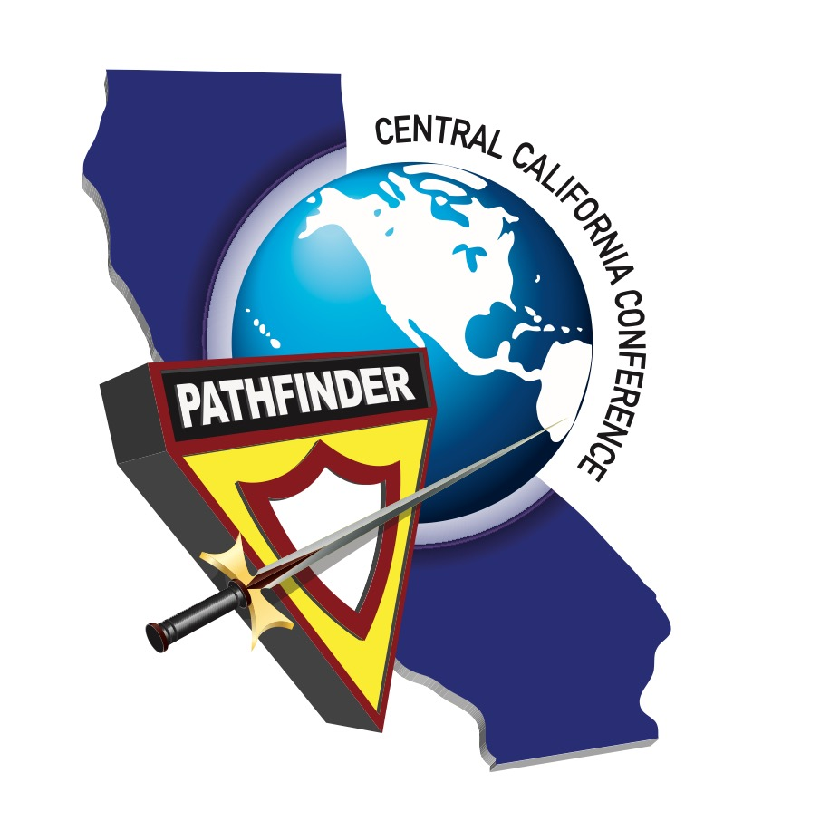

Central California Conference Jr Youth Ministry Department –
Club Trip/Outing Binder Checklist

- Date
- Church & Club Name
- Name of Director
- Contact Number
- E-mail
- Dates of Traveling
- Copy of Detailed Itinerary
- Copy of Insurance Documents
- Copy of Background Checks for ALL Adult Attendees
- Copy/Date of Church Board Action
- Copy of Budget
- Consent Letter Signed by Parents
- Medical Consent/Allergies/Medicine
- Mode of Transportation
- Number/List of ALL Participants

Director Signature Date

